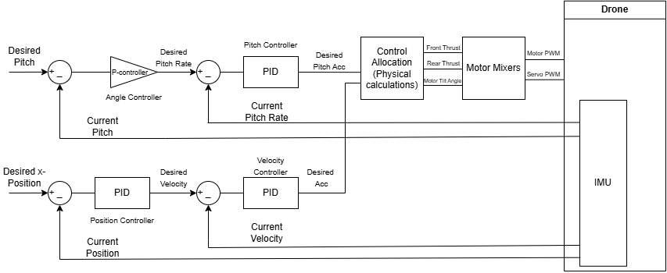

/* * LongitudinalController.h
* Integrates ArduPilot inputs with your Left-Facing Simulink Math
*/

class LongitudinalController {
public:
struct Outputs {
float desired_ax_sim; // Accel in Sim-frame (Left = Positive)
float desired_theta_acc; // Pitch Accel (Nose Up = Positive)
};

Outputs update(float target_x_real, float current_x_real,
float current_vx_real, float target_pitch,
float current_pitch, float current_pitch_rate,
float dt)
{
// ============================================================
// THE COORDINATE FLIP
// ArduPilot: Forward = +X | Your Model: Forward = -X
// ============================================================
float current_x_sim = -current_x_real;
float current_vx_sim = -current_vx_real;
float target_x_sim = -target_x_real;

// 1. POSITION CONTROLLER (Outer Loop)
// If real error is (5 - 2) = 3m forward, sim error is (-5 - -2) = -3m
float pos_error = target_x_sim - current_x_sim;
float target_vel_sim = pid_pos.update_all(pos_error, dt);

// 2. VELOCITY CONTROLLER (Inner Loop)
float vel_error = target_vel_sim - current_vx_sim;
float out_ax_sim = pid_vel.update_all(vel_error, dt);

// 3. ANGLE CONTROLLER (Outer Loop - P Only)
// Keep Pitch as is (Nose Up = Positive)
float angle_error = target_pitch - current_pitch;
float target_pitch_rate = angle_error * kP_angle;

// 4. PITCH RATE CONTROLLER (Inner Loop)
float rate_error = target_pitch_rate - current_pitch_rate;
float out_theta_acc = pid_rate.update_all(rate_error, dt);

return {out_ax_sim, out_theta_acc};
}

private:
CustomPID pid_pos;
CustomPID pid_vel;
float kP_angle = 3.0f; // Example gain
CustomPID pid_rate;
};

struct AllocationOutputs {
float Tf; // Total Front Thrust (Newtons)
float Tr; // Total Rear Thrust (Newtons)
float alpha; // Tilt Angle (Radians)
};

AllocationOutputs calculate_allocation(float ax_sim, float theta_acc_req, float theta) {
// These are your ORIGINAL left-facing constants and equations
const float m = 4.9;
const float I = 0.158;
const float L = 0.459;
const float c = 0.1;
const float g = 9.81;

// Forces required in SIMULINK coordinates
float Mreq = I * theta_acc_req;
float Rx = m * ax_sim; // No minus sign here! ax_sim already has the flip.
float Ry = m * g;

// EXACT equations from your Simulink 'A' and 'B' blocks
float A = Mreq - L*(1-c)*(Ry*cos(theta)) - L*(1-c)*(Rx*sin(theta));

float B = -L*(1-c)*Ry*sin(theta) + L*(1-c)*Rx*cos(theta)
+ c*L*(Rx*cos(theta) - Ry*sin(theta));

float alpha = atan2(-B, A);

// Matrix Solver for Tf and Tr (Original logic)
float det = sin(alpha + theta)*cos(theta) - sin(theta)*cos(alpha + theta);

float Tf, Tr;
if (abs(det) < 0.001f) {
Tf = Ry * (1.0f - c);
Tr = Ry * c;
} else {
Tf = (Rx * cos(theta) - Ry * sin(theta)) / det;
Tr = (Ry * sin(alpha + theta) - Rx * cos(alpha + theta)) / det;
}

return {Tf, Tr, alpha};
}

void apply_final_mixer(float Tf, float Tr, float alpha, float roll_cmd) {
// --- 1. CONFIGURATION CONSTANTS ---
const float COAX_FACTOR = 1.6f; // 2 motors = 1.6x thrust
const float MAX_MOT_NEWTONS = 30.0f; // Max thrust of one motor at 100%
const float SERVO_CENTER_PWM = 1500.0f; // Mid-point
const float SERVO_RANGE_PWM = 500.0f; // Range for 90 degrees

// --- 2. FRONT SYSTEM (4 MOTORS) ---
// Split total Tf between Left and Right, then divide by coax factor
float base_f_newtons = (Tf / 2.0f) / COAX_FACTOR;

// Convert Newtons to normalized 0.0 - 1.0 (ArduPilot style)
// We add/subtract roll_cmd (0.0 to 1.0) here for lateral stability
float throttle_L = (base_f_newtons / MAX_MOT_NEWTONS) + roll_cmd;
float throttle_R = (base_f_newtons / MAX_MOT_NEWTONS) - roll_cmd;

// Constrain to safe limits
throttle_L = fmaxf(0.0f, fminf(1.0f, throttle_L));
throttle_R = fmaxf(0.0f, fminf(1.0f, throttle_R));

// Front Left Coaxial Pair
hal.rcout->write(0, throttle_L); // Motor 1
hal.rcout->write(1, throttle_L); // Motor 2

// Front Right Coaxial Pair
hal.rcout->write(2, throttle_R); // Motor 3
hal.rcout->write(3, throttle_R); // Motor 4

// --- 3. TAIL SYSTEM (2 MOTORS - INDEPENDENT) ---
// Tr is handled by Motor 5 (Upward) or Motor 6 (Downward)
float throttle_rear = fminf(1.0f, fabsf(Tr) / MAX_MOT_NEWTONS);

if (Tr >= 0) {
hal.rcout->write(4, throttle_rear); // Motor 5 (Top) - Pushes UP
hal.rcout->write(5, 0.0f); // Motor 6 (Bottom) - OFF
} else {
hal.rcout->write(4, 0.0f); // Motor 5 (Top) - OFF
hal.rcout->write(5, throttle_rear); // Motor 6 (Bottom) - Pushes DOWN
}

// --- 4. TILT SYSTEM (2 SERVOS - MIRRORED) ---
// alpha is in radians from your math.
// If alpha is positive, we want the motors to tilt forward.
float alpha_deg = alpha * (180.0f / M_PI);
float servo_offset = (alpha_deg / 90.0f) * SERVO_RANGE_PWM;

// Mirrored Geometry: If Left needs +offset to tilt forward,
// the Right servo (facing the other way) usually needs -offset.
float pwm_L = SERVO_CENTER_PWM + servo_offset;
float pwm_R = SERVO_CENTER_PWM - servo_offset;

hal.rcout->write(6, (uint16_t)pwm_L); // Servo Left
hal.rcout->write(7, (uint16_t)pwm_R); // Servo Right
}

